34.112: First recall that 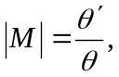and that 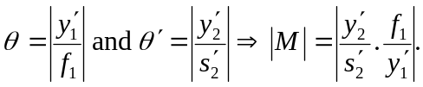
But since the image formed by the objective is used as the object for the eyepiece,
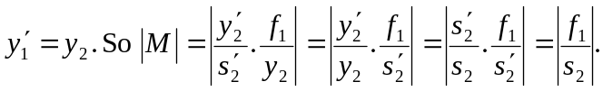
Therefore, 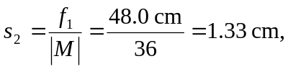and this is just outside the eyepiece focal point.
Now the distance from the mirror vertex to the lens is 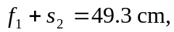and so 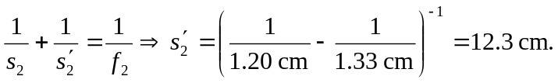 Thus we have a final image which is real and 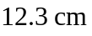from the eyepiece. (Take care to carry plenty of figures in the calculation because two close numbers are subtracted.)

